FISHING PHOTOGRAPHY 101

We here at TFI, practice catch and release a lot of the time. It’s getting more and more important to keep those fish in the water to let them spread those genes out there and increase the population….especially trophy sized genes which aren’t so common anymore. With the popularity of catch and release growing every day, the importance of that perfect photo becomes greater and greater. With some simple tips, you can really get that perfect photo to document your catch, your trip and anything else you see.

KNOW YOUR GEAR

With the advent of digital cameras, everyone can own a very functional and feature packed camera for a fairly reasonable price. This is great, but you still need to know how to use it! Granted, you can get away with full auto mode, and still get decent images, but with a little reading of your manual, snapshots can turn into great photos!!

First things first, know your camera….how it works, how to change the settings quickly. Once you know this, do the idiot checks. Are your batteries charged? Do you have space on your memory cards? Do you have the camera settings where you want them to start the day? All of this has come back to bite me before. Great catch, pull out camera, batteries dead! No space on the memory card, so now I have the moral dilema of erasing a few photos of grandpa’s 90th birthday vs. my 150lb Tarpon. The point is, take a little time the night before a trip to make sure your ducks are in a row.

Now that you have everything set-up correctly, make sure you can get to your camera without 5 minutes of looking and digging. They make plenty of very weatherproof cases these days, and even in the roughest situations there is no reason to have it buried underneath 2 extra sets of clothes, a towel, and your lunch. In the last few years, the waterproof point-and-shoot has made great strides with many choices. As a strictly boat/fishing camera these are hard to beat. They are often crush proof, drop proof, work in extreme temperature ranges and of course waterproof.

If you can afford it, which most can with the price of memory cards having come way down, always bring along a few extra memory cards on a trip. You never know when one might fail on you, and you can also pull one at the end of the day to keep it on dry land and safe while you take another one out for the second days trip. In the same vein, extra batteries are also I great idea to have with you, especially if you’ll be somewhere remote on a multi-day trip.

Another often overlooked consideration should be the temperature and humidity where the camera is and where it will be used. If these differ greatly it can often end up with condensation on the lens and a blurry photo. Just like a fish in an aquarium, let your camera acclimate and get used the environment it will be used in. It shouldn’t take long, but if not done it could ruin a photo.

LIGHTING
Unless you are looking for a sillouette or just trying to get creative, keeping the sun behind you while taking a photo is your best overall bet. I would argue that a 45 degree angle off of your back would be ideal and will keep your subject from having to stare directly into the sun(and the squinting that goes with it) if you had the sun directly at your back. Remember too, the sun itself has a different “color” depending on time of the day. In the morning and evening, those light rays have to pass through a lot more of the atmosphere which “warms” up the light and give you that great yellow tone. Typically the least interesting light is at high noon…where there are no shadows, and no warmth.

Flash…also consider using your flash at all times. Even the best of us get caught taking a photo without the sun in the right place, and it can do wonders to have the flash on to fill in some of the those shadows on your face and fish. Also is you are looking for that sunset/sunrise in the background shot, the only way to do it and get some detail on the angler is to use your flash.

COMPOSITION

Your typical fishing photo is a guy with a fish centered in the middle with plenty of space on all sides of the frame. This, while technically documenting the catch, is frankly really boring and uninspiring. First let’s take on the centering. There is something in photography referred to as the rule of thirds….basically think of drawing lines through the frame to divide it into thirds both horizontally and vertically. If taking a landscape(horizontal) photograph of an angler for example, put him on one of those vertical lines, not in the dead center.

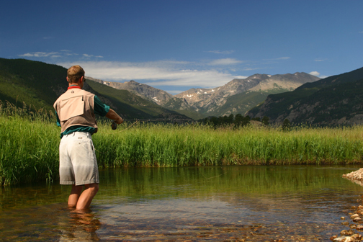

Get in there…Fill the frame as much as you possibly can for that fish holding photo. Unless you purposely want to get some of the background in as reference or beauty, you want to concentrate on eliminating as much of the background as possible. You don’t want a little guy and fish, in a big from of nothing but water. So before you snap that shot, zoom In as far as you can(without getting into the digital zoom), and fill that frame corner to corner with your angler and his catch.

GET CREATIVE

There are many ways to get some interesting images to document your day on the water if you are willing to get a little creative.

Macro…Getting in really close on an eye, or a fin, with or without a macro lens(a lens that can get very close to the subject) can produce some really interesting results that can be visually stunning. But that isn’t limited to higher end cameras, most point and shoots have a macro mode(typically a flower looking icon), you just have to find(as in KNOW YOUR CAMERA)

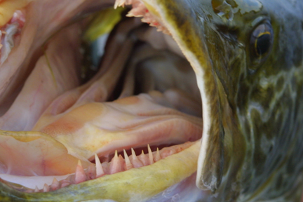

Focus…Be conscious of focus, both in being creative and documenting the day. If it’s a photo of someone holding a fish, make sure your focus is on the fish. I have more than one photo where the focus is on the background, or even me, and the fish is out of focus…that’s no good! On the other hand, if you want to get more creative, you can play around with short focus…blurring out certain parts of the image on purpose for affect like this with the longest lens you have on your camera. By playing with the focuse you can really make certain things pop.

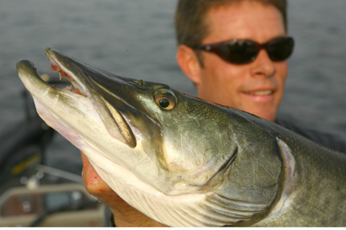

Angle…think about the angles you are shooting the subject from, and play with them. Take one from way below your subject shooting up with the sky as a background, take another at the same level. You’ll find that the same guy with the same fish can look 100% different if you just play around a bit. Remember, fish will always look bigger from a lower angle.

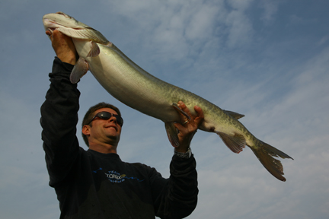

Holding fish…. The hold itself, depends a lot on the type and size of fish, and if you intend to keep it or catch and release. If you choose to catch and release, which we mostly do here at TFI, you need to be conscious of how you support the fish and how long it’s out of the water. A pretty good rule for catch and release is hold your breath(or imagine doing so) when you bring the fish out of the water, when you’re out of breath the fish probably is too and should go back in the water. Also, remember these fish deal with a lot lest gravity and are horizontal 99% of the time. Meaning, if you take a king mackeral for example, and hoist him up by the jaw, this puts all the fishes weight on those jaw muscles and connective tissue, as well as causing the organs inside to slide towards the tail….both causing harm to the fish. Outside of the harm done, a fish which is that body shape(more long and skinny), will almost always look better photographed being held horizontally in front of you, within a horizontal photo. In these horizontal holds, for a better photo, try and tuck as many fingers and thumbs behind the fish as possible, remember the idea is to display as much of the fish as possible. Also be wary of the gill plates and eyes, and doing any damage there.

Old Straight arm the size helper…Often argued about , the other time tested “helper” of fishing photos is the arm extension to give that fish a little bit more umph size wise. Now I admit I’ve done it before to varying degrees, and the deal is this. If you are showing the photo to other fisherman, they will know what you’re doing and will most likely give you flack about it, but if you are showing it to the non-angler it can add a bit of wow factor to the fish. The key to keep in mind if you’re going to do it, is to hide those elbows...if someone can see your arm is straight out from your body with no bend reaching towards the camera, well, you just look silly and like you’re trying way too hard. Often times a happy medium of some extension in the arm, but nothing extreme is the way to go.

Distractions…Before you push that shutter button, take a quick look around the frame for any distractions…a random branch, a rod running through frame, a beer can, blood, a fluorescent bobber then get rid of it!! The whole point of the fish photos is the fish and the angler, and anything else will be a distraction.

DOCUMENT THE “WHOLE” TRIP

Yes, you are there to fish, and are taking photos as your trophy catch of the days, but as anglers so many other things happen out there on water that are just as important, just as beautiful or memorable so keep your eyes open. The obvious ones are the great natural things that most anglers get to see, whether it’s a mountain, tree, moose, whale, osprey, or a shark eating your tarpon, but don’t forget the things that made the trip memorable and capture them. The less obvious ones….maybe there is a special backpack that has survived three trips overboard, take a picture of it floating out there. Maybe everyone on the trip has laughed every time someone has hit their head on a part of the T-top….or the hotel room you’ve been relegated too has a jon in the living room or someone brought a jig up with a starfish and mussels.…..document it. It may sounds strange, but it’s those little memories that were part of your trip that you’ll soon forget, but with a visual record of it, you can relive the “whole trip” for years to come.

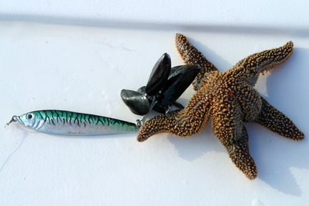

IT’S DIGITAL SO JUST KEEP SHOOTING

Long gone are the days of film and developing costs, so don’t be bashful about firing as many shots as you can during a special moment to try and capture. It only takes a button push to eliminate a photo, but you can’t go back and capture a once in a lifetime moment if you’ve missed by being stingy with the shutter button. This especially applies to those shots of fighting the fish, landing the fish, and releasing the fish….so much is going on and there are so many variables, getting that perfect shot is often the results of shooting the entire event and finding that one photo where the stars align and you can see the right look on the anglers face, the fish clearly, etc. To a lesser extent this still applies to the actually fish photo as well…if you’ve got an angler that’s excited or struggling to hold a fish, and a fish that wriggling to get away, it’s often tough to take one shot and get everyone looking how you’d like. So just keep shooting!!! I would have never captured the photo below without a whole bunch of photos to get that perfect moment.

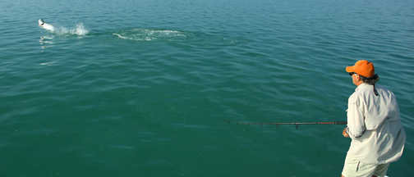

Well, that’s at least a start on getting some great photos out of your next fishing trip. With a little preparation and a little thought before you push down that shutter button, you can really have a set of great images that will let you relive every aspect of your trip. So charge those batteries, check those memory cards and get out and have the time of your life.

Tight lines,

~J

